Latin America Geography Graphic Organizer

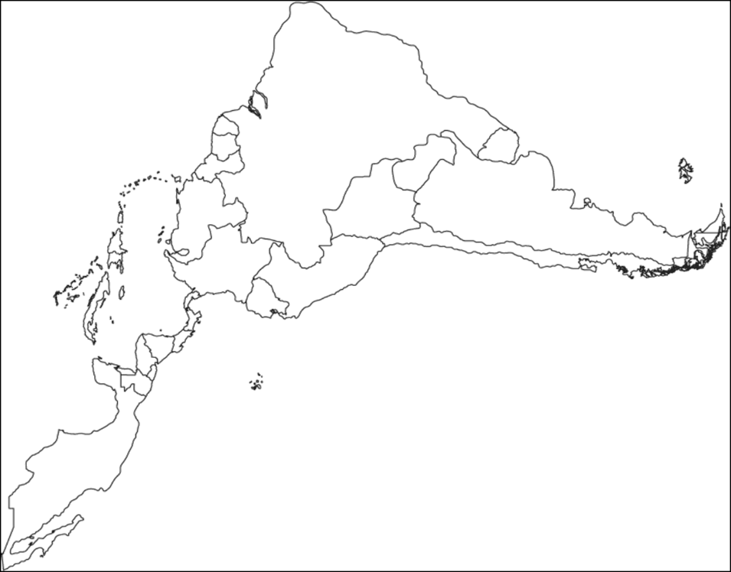

Amazon River, Caribbean Sea
Gulf of Mexico
Pacific Ocean
Panama Canal
Andes Mountains
Sierra Madre Mountains
Atacama Desert

.
Bolivia Brazil Colombia Cuba Haiti Mexico Panama Venezuela

